MID_TERM REPORT

**Subject: Project 2**

|  |  |
| --- | --- |
| Description | Project Specification  Building and describing use case diagram  Building Database |
| Group | P2_06 |
| Class | LTU12A |
| Time | 24/3/2017 |

Contents

THE WORK COMPLETED AND DIVISION OF THE GROUPS 4

PROJECT SPECIFICATION 6

ANALYZING PHASE 7

General use case diagram. 9

Detailed use case diagram 9

Constraints and Algorithms for Constraints 28

DATABASE 35

1. Database 36

2. Database for usecase. 36

39

UI 46

# THE WORK COMPLETED AND DIVISION OF THE GROUPS

|  |  |  |  |
| --- | --- | --- | --- |
| SSTT | Nội dung công việc | Người thực hiện | Mức độ hoàn thành |
| 1 | Giao diện cho các usecase | Cường , Phương | Đã tạo được 23 trang giao diện tương ứng với các usecase |
| 2 | Vẽ biểu đồ Class Diagram | Phương | Hoàn thành sơ bộ với |
| 3 | API | Quý | Đã hoàn thành API cho tất cả các usecase và các giàng buộc liên quan. |
| 4 | Database | Mai, Quý | -Hoàn thành xong database (23 bảng)  -Đã nhập liệu đầy đủ(có filedata kèm theo) |
| 5 | Phân tích thiết kế, hoàn thành mô tả usecase. Các ràng buộc, ngoại lệ. | Mai | -Có 18 usecase chính  -Có thêm các usecase phụ ở phân dã mức 2  -Đã mô tả đầy đủ ngoại lệ cho các usecase(trong phần báo cáo)  -Đã tạo các ràng buộc giữa các usecase và các actor ( gồm 16 ràng buộc-thêm 2 ràng buộc so với buổi trước) |

# PROJECT SPECIFICATION

**Project name**

Building internship process management website for SIE

**Requirements**

Building website for managing internship process of SIE’s students.

Complete product (beside project’s source code) is a website which is deployed on web server/cloud server (localhost is not permitted). This website need to provide these following functions for these user groups:

**- Student:**

Adding/Editing CV

Viewing list of internship topics

Filling internship register form

Responding to internship process

Submitting half semester/semester internship report

Tracking internship rating status

Viewing internship mark

- **Company’s agent:**

Release internship topics list

Filling acceptance form for receiving student

- **Company’s instructor:**

Submitting detailed draft

Rate according to the standard

Comment/response according to the standard

- **Internship** manager teacher

Comparing student’s expectation/destination company

Planning/Arranging internship program by multiple periods

Analyzing student’s internship process

- **Instructor:**

Giving marks

Communicating with company’s instructor

Website administrator

- **User management:**

Student must use school email, company must use company’s email

Social networks login

Mark management

Auto configuration:

Auto notify user for giving mark, response via email, SMS, FB,..

Comparing student’s expectations and destination company

# ANALYZING PHASE

**Making use case diagram**

**List of actors and functionalities of the system**

|  |  |
| --- | --- |
| **Order** | **Actor** |
| **1** | Student |
| **2** | Company’s agent |
| **3** | Company’s instructor |
| **4** | Internship manager teacher |
| **5** | Instructor |
| **6** | Admin |

**List of the main use case.**

|  |  |
| --- | --- |
| **Usecase** | **Use Case Name** |
| **UC0** | Register |
| **UC1** | Login |
| **UC2** | CV Management |
| **UC3** | Internship registering |
| **UC4** | Internship responding |
| **UC5** | Submit internship report |
| **UC6** | Topic management |
| **UC7** | Filling accepting student form |
| **UC8** | Internship Student management |
| **UC9** | Detailed report management |
| **UC10** | Assign Internship Decision |
| **UC11** | Reckoning up internship status |
| **UC12** | Communication |
| **UC13** | User management |
| **UC14** | Mark management |
| **UC15** | Giving mark |
| **UC16** | Logout |
| **UC17** | Reckoning up internship registration status |

## General use case diagram.

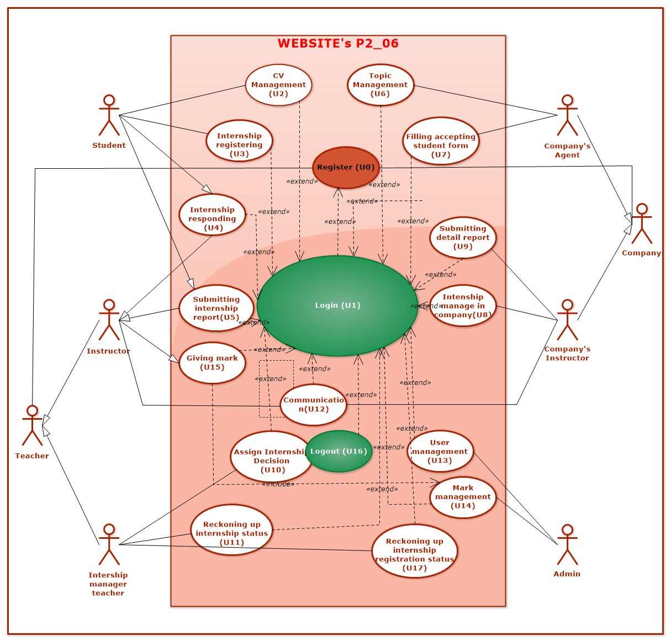

## Detailed use case diagram

**UC1 (Login)**

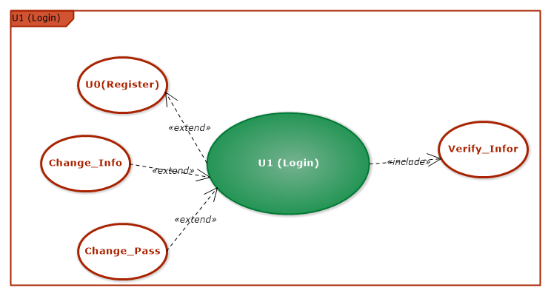

|  |  |
| --- | --- |
| Use Case name | Login (U1) |
| Main Actors | Students, Company’s Agent, Company’s Instructor, Internship Manager Teacher, Instructor, Admin. |
| Level | 1 |
| Purpose | Guarantee that user’s authentication and system are safe |
| Precondition | User had an valid account |
| Success confirmation | Valid credentials |
| Activate | User login successfully |
| Main events | Displaying login form  User filling his credentials  Checking/verifying valid credentials  Successfully login messages |
| Exceptions | Warning if credentials is not valid  Refilling credentials |

**UC2 (CV Management)**

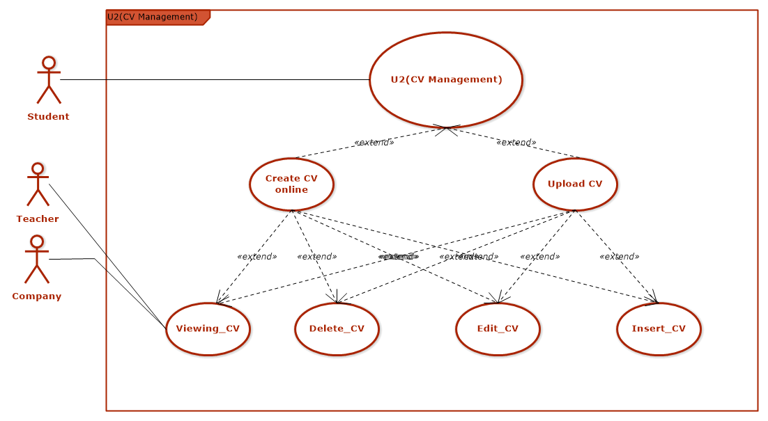

|  |  |
| --- | --- |
| Use Case name | U2 (CV Management) |
| Main Actors | Student |
| Level | 1 |
| Purpose | Supporting student for easily manage their CV |
| Precondition | Student has logged in successfully |
| Activate | Student updated their CV successfully |
| Main events | 1. Student access to CV management section  2. Student choose “Create CV online/Upload CV”  3. Student review and modify their CV (if needed)  4. CV will be submitted and teacher/company are authorized for getting CV contents.  4. Logging out |
| Exceptions | 1. User hasn’t logged in with an authorized email |

UC5(Submitting internship report)

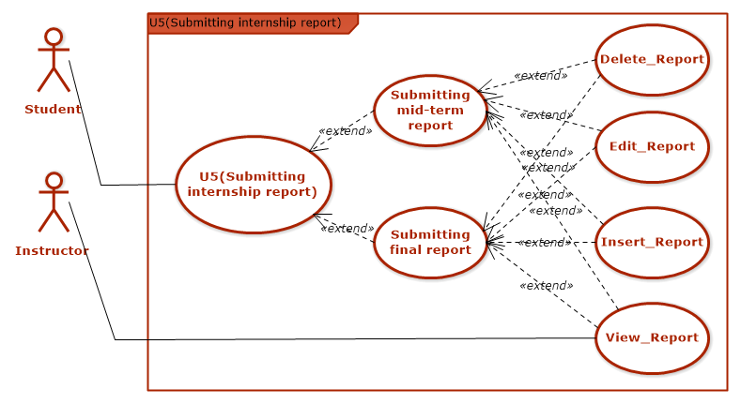

|  |  |
| --- | --- |
| Use Case name | U5 (Submitting internship report) |
| Main Actors | Student |
| Level | 1 |
| Purpose | Supporting student for submitting report punctually |
| Precondition | Student has logged in to system successfully |
| Activate | Student has correctly submitted mid-term and final report |
| Main events | 1. Student logging in to system  2. Student clicks to “Submitting mid-term/final report” section  3. Student choose their report file for submitting.  4. Student clicks submitting.  5. Student review their report.  6. Student can modify their report before submitting  7. Student’s report will be submitted, teacher can give a mark  8. Exiting use case |
| Exceptions | 1. Report submitting is overdue  2. Report is not correctly formatted  3. User hasn’t logged in with an authorized email |

**UC6 (Topic Management)**

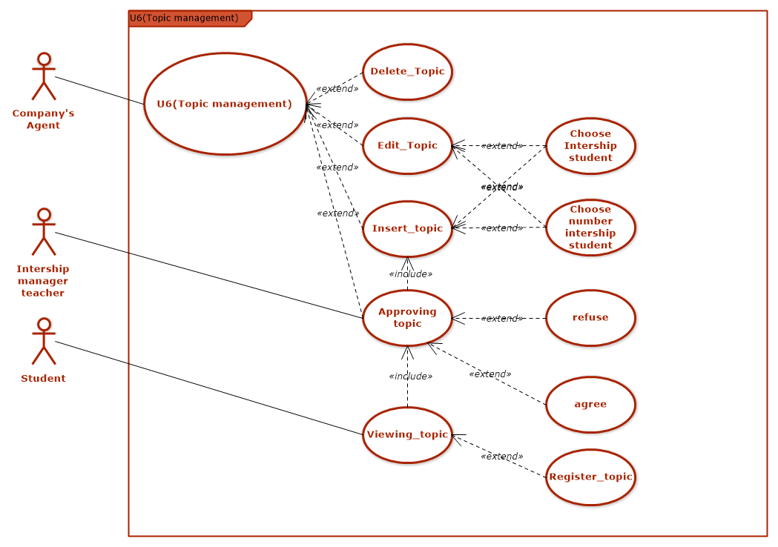

|  |  |
| --- | --- |
| Use Case name | UC6 (Topic management) |
| Main Actors | Company’s Agent , Internship manager teacher |
| Level | 1 |
| Purpose | Supporting company in registering internship topic, internship manager teacher can manage internship topics and select what topic will be suitable for students. Student can view and register his favorite topics |
| Precondition | Student has logged in to system successfully |
| Activate | Internship topic has been submitted successfully and student can read and register |
| Main events | 1. User access to topic management tab  2. Company’s Agent select Insert_Topic/Edit_Topic/ Delete_Topic/Viewing_Topic.  3. Company’s Agent filling topic information. (if he selects Insert/ Edit_Topic)  4. Company’s Agent enter the number of student needed for topic or select certain students based on student’s id (if he selects Insert/ Edit_Topic)  5. Internship manager teacher will access to “Approving topic” to decide which topic will suitable for student’s ability, student’s time and selects approve/reject these topics  6. Company’s Agent will recheck and fix these topics in teacher’s demand then click “Save”  7. Topics list will be displayed on system’s view, allowing student to access and carry out activities  8. Exiting Use Case |
| Exceptions | 1. Registering topics is overdue  2. Company is not correctly register topics  3. Student choose more than 3 topics or topic is not available for register (because there is too much student registered that topic)  4. Internship manager teacher can not approve topic when company’s agent has not submitted topics.  6. Student can not see topic when Internship manager teacher has not approved topic  7. User hasn’t logged in with an authorized email |

**UC8 (Internship student manage)**

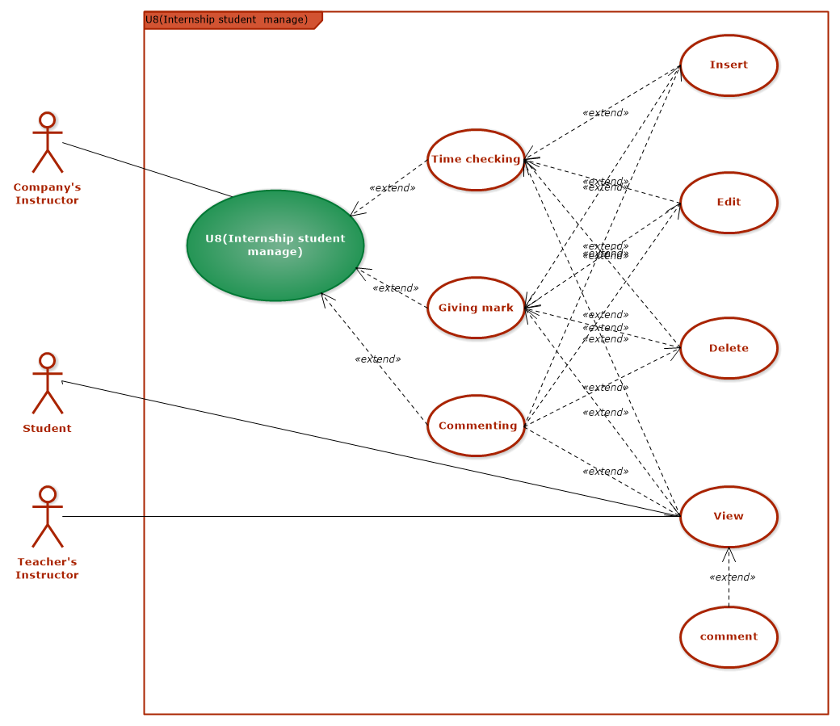

|  |  |
| --- | --- |
| Use Case name | UC8 (Internship manage in company) |
| Main Actors | Company’s Instructor |
| Level | 1 |
| Purpose | Supporting Company’s Instructor, Teacher’s Instructor for tracking student’s internship progress regularly, make judgement on student’s work in company. Student can also track their own progress |
| Precondition | User logging in to system |
| Activate | Complete commenting for student’s internship program, time checking for student  Instructor Teacher and Student can get student’s result in their system |
| Main events | 1. Company’s Instructor access tab “Internship manage in company”  2. Company’s Instructor selects tab Time checking/ Commenting / Giving mark  3. Company’s Instructor enter comment/ mark/time checking for student  4. Company’s Instructor review filled field and click submit.  5. Company’s Instructor information which entered will be submitted to system  7. Instructor Teacher and Student can access and get the comment, mark that Company’s Instructor has given  8. Student can comment if they think that is not suitable  9. Exiting Use Case |
| Exceptions | 1.User hasn’t logged in with an authorized email |

**UC9 (Submitting detailed report)**

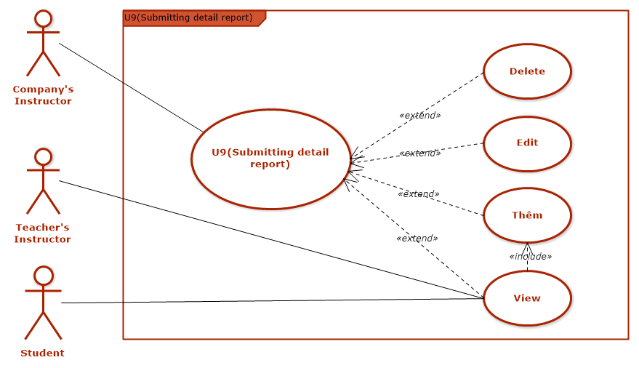

|  |  |
| --- | --- |
| Use Case name | UC9 (U9(Submitting detail report)) |
| Main Actors | Company’s Instructor |
| Level | 1 |
| Purpose | Supporting Student, Teacher’s Instructor to know student’s detailed work content weekly, monthly for arranging suitable work schedule, preparing necessary knowledge, and help Instructor teacher, Company’s Instructor tracking student’s daily, weekly and monthly work easily |
| Precondition | User logging in to system  Company’s Instructor’s submitted topics has been approved by teacher |
| Activate | Company’s Instructor submitted detailed report successfully.  Instructor Teacher and Student can get detailed report’s content |
| Main events | 1. Company’s Instructor access to “Submitting detailed report” functionality  2. Company’s Instructor choose file format  3. Company’s Instructor choose file to upload  4. Company’s Instructor click “Save”  5. Company’s Instructor review detailed report and modify if necessary  6.Detailed report will be submitted to system  7. Instructor Teacher and Student can access to get the content of detailed report and student’s work  8. Exiting Use Case. |
| Exceptions | 1. Instructor Teacher and Student can not get detailed report’s content if Company’s Instructor has not uploaded detailed report successfully  2. Company’s Instructor is not punctually submitted report  3. Company’s Instructor uploaded file which is not correctly formatted  4. User hasn’t logged in with an authorized email. |

**UC10 (Assign Internship Decision)**

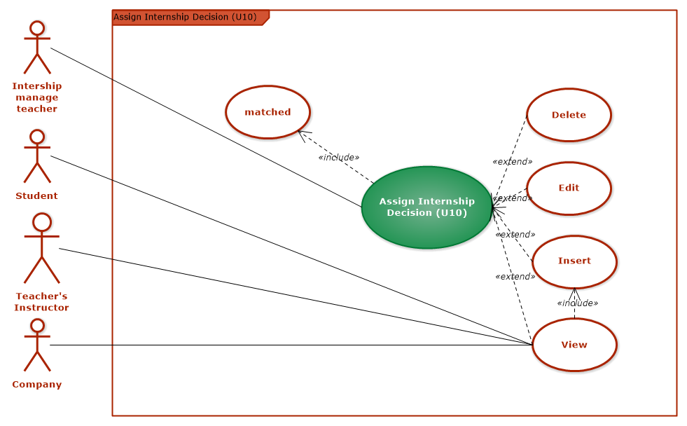

|  |  |
| --- | --- |
| Use Case name | UC10(Assign Internship Decision) |
| Main Actors | Internship manager teacher |
| Level | 1 |
| Purpose | Arranging topic that suitable for student and school’s rule |
| Precondition | 1.User logging into system  2. Comparing process between topic and student’s CV is successfully |
| Activate | Arranging process is successfully, students will be placed for suitable company, Instructor Teacher and Student can get internship program content |
| Main events | 1. Instructor manager teacher access arranging internship functionality  2. In this section, with each student, will be displayed topics, company information about registered company, and the suitable percentage with student. Instructor manager teacher will select topic which is most suitable for student  3. After complete filling, Instructor manager teacher click Save.  4. Instructor manager teacher review arranging internship’s content and modify if necessary.  5. Arranging internship’s content will be submitted to system  6. Instructor Teacher , Company’s Instructor and Student access to arranging internship’s content and get the result |
| Exceptions | 1. User hasn’t logged in with an authorized email.  2. Can not get the arranging internship’s content if Intership manager teacher has not saved arrange internship function |

**U11 (Reckoning up internship status)**

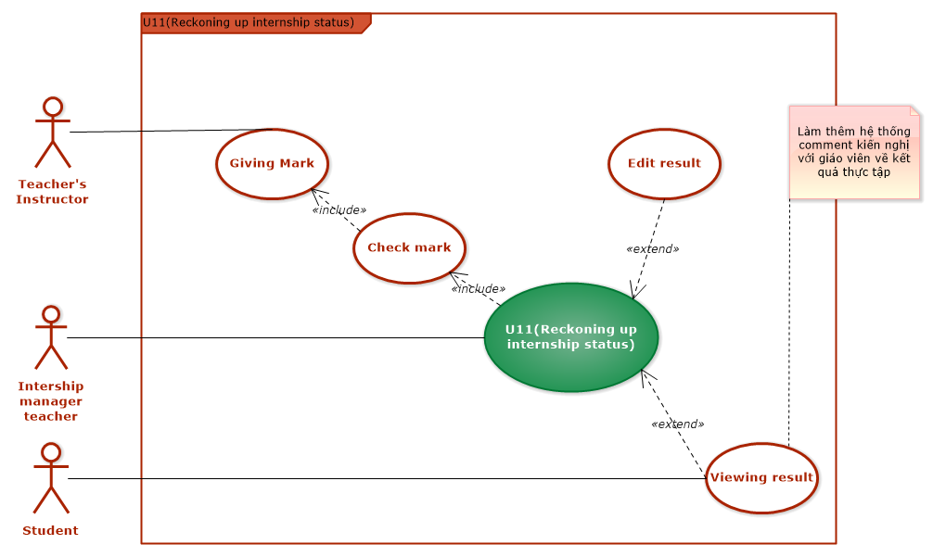

|  |  |
| --- | --- |
| Use Case name | UC11 (Reckoning up internship status) |
| Main Actors | Internship manager teacher |
| Level | 1 |
| Purpose | Through this functionality, Internship manager teacher and student can tracking and getting the student’s result (completed/not completed). If not completed, the student must registered on the next semester |
| Precondition | 1. User logging into system  2. Instructor Teacher has submitted student’s mark to system  3. System processed checking mark ( sum < 4 means not completed) |
| Activate | Listing all students that  + completed internships  + haven’t completed internships  + delay and delay reason ( submitted all required documents and has been approved) |
| Main events | 1. Instructor manage teacher access to section “Reckoning up internship status”  2. Instructor manager teacher review result of internships student  3. Instructor manager teacher check students who has good reasons for delaying, for editing the result to “delay”  4. Instructor manager teacher click “Save”  5. Internship status is submitted to system.  6. Student get their own result  7. Exit usecase. |
| Exceptions | 1. . User hasn’t logged in with an authorized email. |

**UC13 (User management)**

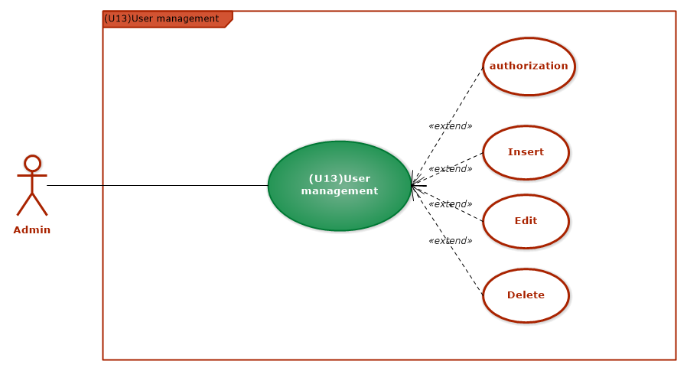

|  |  |
| --- | --- |
| Use Case name | UC13 (User management) |
| Main Actors | Admin |
| Level | 1 |
| Purpose | Managing all system’s user, authorizing user for gaining right accessibility |
| Precondition | Successfully login and can access to all functionalities of the system |
| Activate | Can manage all users, gaining right access for right user |
| Main events | 1. Admin access to “Manage user” section  2. Check for the registering of all user who have been registered based on their email and decentralize the functionalities to every specific group of user.  + Mail: student_num.student.hust.edu.vn will gain the functionalities for student  + Mail: teacher.soict.hust.edu.vn will gain the functionalities for teacher  + Mail with enterprise domain will gain the functionalities for company’s agent or the functionalities for company’s instructor.  3. After the decentralization, click “Save” button.  4. Admin can modify if there is any errors  5. Exiting use case |
| Exceptions | 1. The user did not use the enterprise mail, or student mail will be notified invalid email |

**UC14 (Score management)**

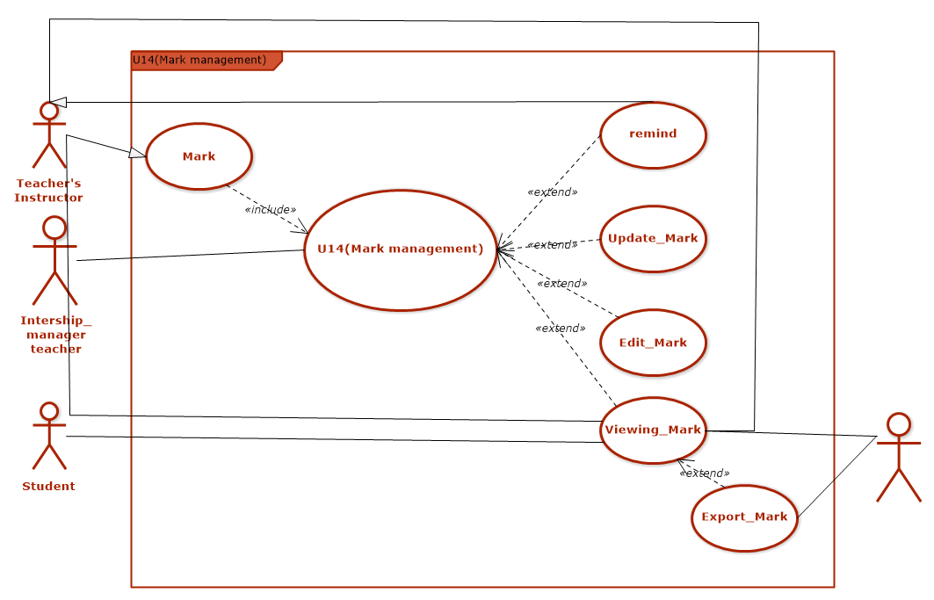

|  |  |
| --- | --- |
| Use Case name | UC14 (Score management) |
| Main Actors | Admin |
| Level | 1 |
| Purpose | Help : Managing mark of all students  functionalities: insert/ edit/ delete student’s mark when student submitting remaking mark and the Instructor teacher’s process of submitting mark has errors  Getting mark for checking mark process, to know who completed/not completed |
| Precondition | Successful login and can access to all functionalities of the system  Instructor Teacher have done process “Giving mark” and display in the system. |
| Activate | Student’s mark posted to the system successfully. |
| Main events | 1. Intership manager teacher access to section “Mark management”  2. Intership manager teacher check whether Instructor Teacher had given mark? If not, check the time for giving mark and notify Instructor Teacher for giving mark  3. Teacher’s Instructor will be notified.  4. If mark submitting process has any errors, Intership manager teacher can modify student’s marks  5. Mark will be submitted to system  6. Student, Teacher’s Instructor , admin access and get the internship marks.  7.Admin can export mark file. |
| Exceptions | 1. Notify if company’s mail, student’s mail is invalid |

**U17 (Reckoning up internship registration status)**

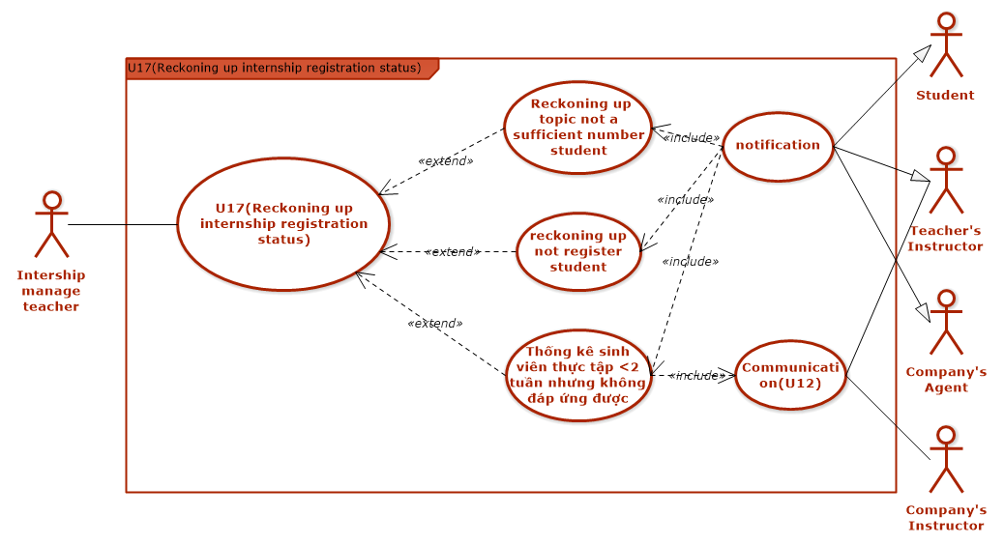

|  |  |
| --- | --- |
| Use Case name | UC17 (Reckoning up internship registration status) |
| Main Actors | Internship manager teacher |
| Level | 1 |
| Purpose | Listing students who has not registered  Listing which topics has not been fully registered  Listing students who is not meet the requirement when working less than two weeks at company  Reopen registration second time |
| Precondition | User logged in successfully  Registration has been closed  Communication result between Instructor Teacher and Company’s Instructor is existed |
| Activate | Getting the full list of student who has not registered for internship, topics has not fully registered, banned students  Give notice: listings students need to register again, the remaining topics list. |
| Main events | 1. Internship manager teacher access to analysis internship registration status  2. Chosen criteria:  Students not registered  Topic insufficient number of students  Students who do not meet the conditions of work at the company after 2 weeks.  3. The system displays a list.  4. Internship manager teacher choose export file  5. Internship manager teacher post a notice on the system  6. Student, Company’s Agent, Teacher’s Instructor get notifications  7. Exit UseCase |
| Exceptions | 1. Error: not reckoning when the system not closed the signup process.  2. Error when not choose criteria. |

## c. Constraints and Algorithms for Constraints

|  |  |  |  |  |  |
| --- | --- | --- | --- | --- | --- |
| Main Usecase | Tied Actor | Tie Actor | **Tie** Usecase | Notes | Processing Algorithm |
| Registering for internship: submitting information | Company’s agent | Teacher who responsible for internship |  |  | Company table will have “is_accept” filed for authenticated value of corresponding company. 0 means not authenticated, 1 is authenticated. Teacher who responsible for internship can update this field |
| Company register internship topic (internship agenda) | Company’s agent | Teacher who responsible for internshipStudent | Approving topic | Approving usecase will be triggerd when company has registered, and can get that topic information after approved by Teacher who responsible for internship | Similar to company register, Top**ic table will have a field for** checking whether that topic has approved. Teacher who has responsibility will manage this |
| Submitting detailed topic report | Company’s Instructor | Instructor, Student | Approving draft, detailed topic |  |  |
| Allocating student for company | Student | Internship undertaking | Comparing |  | Splice skill in student’s cv and compare to skill required of company. Fields which have the same skill name will check the value of student’s skill and company’s required skills. After that, medium value will be used to release comparing value |
| Student reports intern result | Internship students | Instructor.Person in responsible in company |  |  |  |
| Checkin/checkout | **Person in responsible in** company | Student | Proposal |  | Person in responsible in company add checkin/checkout table to database following the gained functons, by create checkin function |
| Fixing mid-term marks | Instructor | Internship undertaking | Giving mark | Time: 1 week after publish | Checking if user has rights to access this function. Update marks, increase check value, if this value > 2, cancel task |
| Internship status responding | Student | Internship undertaking |  |  | Assign to comment section |
| Register to accepting sutdents | **Company’s** agent | Student, Teacher who responsible for internship | Registering for internship topics | Company’s agent when registering topic, can choose students he wants | Người phụ trách thực tập được quyền đăng ký nhân sinh viên gửi yêu cầu phân công thực tập theo đề tài, tên người phụ trách công ty và tên sinh viên lên và lưu vào bảng phân công, sau đó giáo viên phụ trách sẽ xác nhận có chấp thuận việc xin nhận sinh viên này hay không. nếu có thì cập nhật thông tin giáo viên phụ trách nếu không xóa đi và phân công lại |
| Internship Analysis | Person responsible for internship | Internship Guider, Student | Giving, checking mark, get internship result |  | Release Internship Table following by existing citerias of status field: 0:not join internship, 1: joined internship, 2: pending, 3: sacked, 4: others |
| Giving mid-term mark | Instructor | Student,  Person who has responsible at company | Student report mid-term internship report  Respond internship status | Instructor give marks for students who have submitted all required materials |  |
| Giving semester mark | Instructor | Student  Person who has responsible at company | Student report for internship  Submitting checkin  Complete paper of forms  Comment of company |  |  |
| Analysis student register for internship status | Teacher who responsible for internship | Student | Internship registering | Analysis for accepted students, pending students, students who is not meet the company’s requirement after 2 weeks |  |
| Company assert internship’s result | Company’s instructor | Instructor,Student | See assert result |  |  |

CLASS DIAGRAM

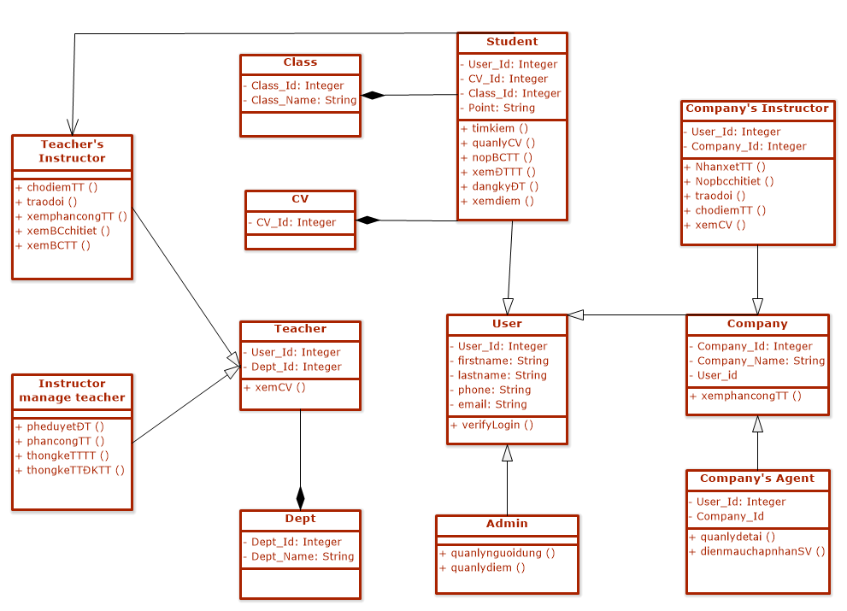

# DATABASE

## 1. Database

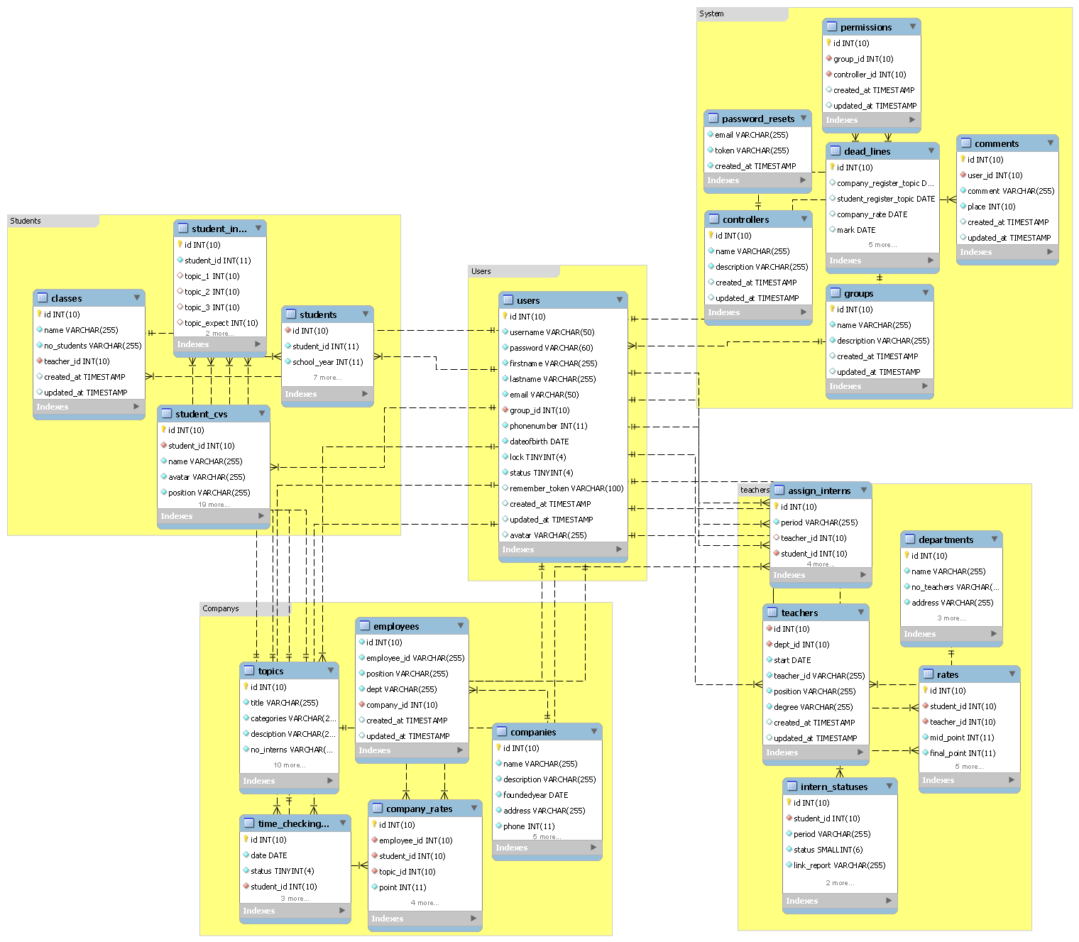

## 2. Database for usecase.

a. Assign_Intership

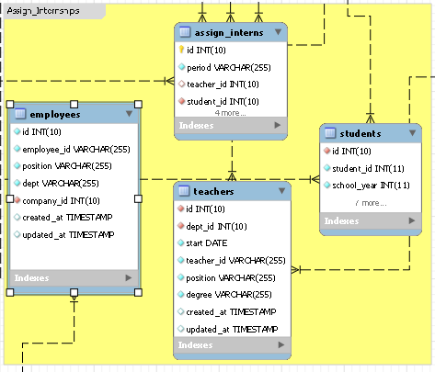

b. CV_management

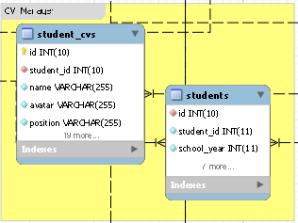

c. Internship student manage

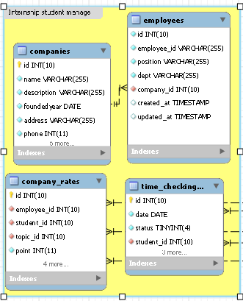

d. Mark management

# 

e. Reckoning up internship registration status.

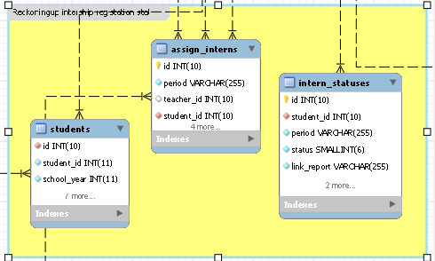

f. Reckoning up internship status

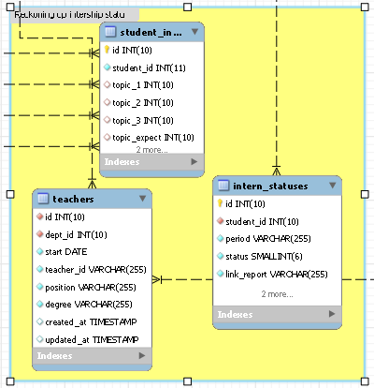

g. Submitting detail report

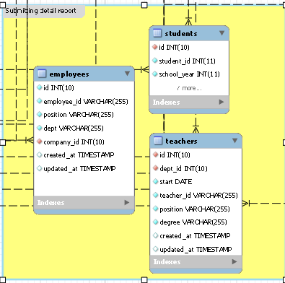

h. Submitting internship report

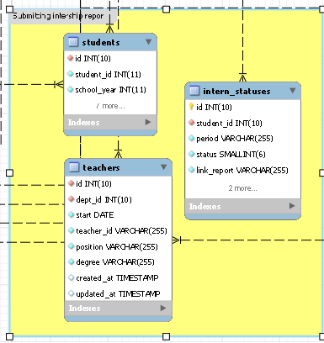

i. Topic Managements

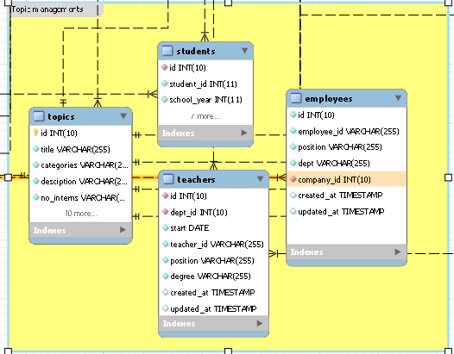

k. User management

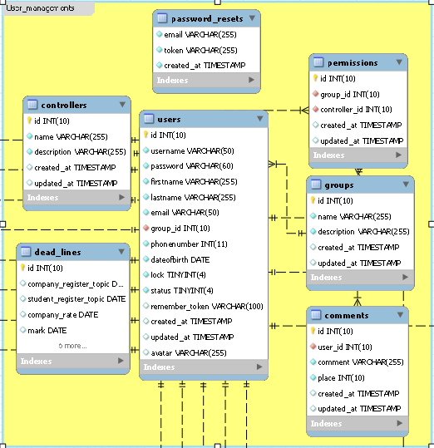

# UI

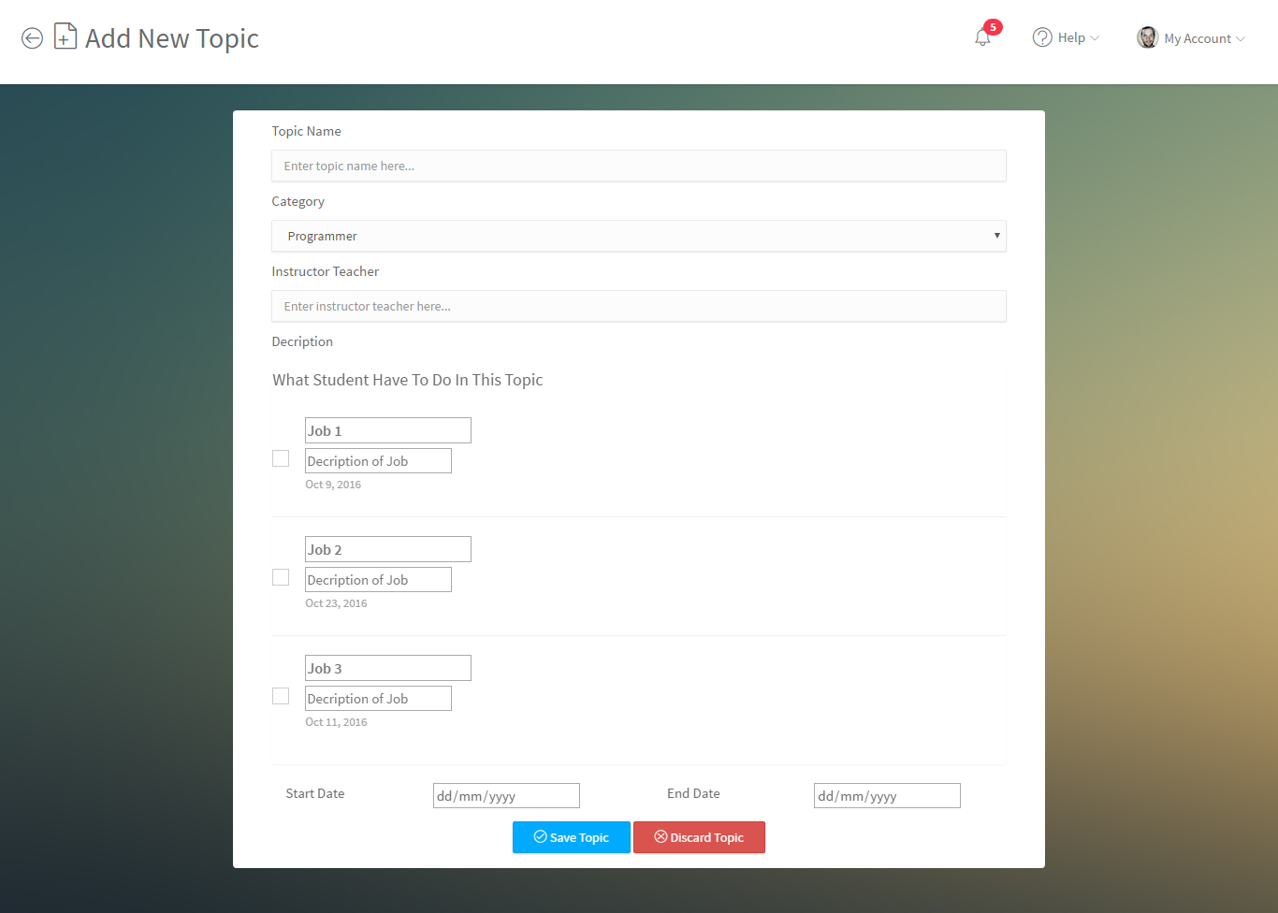

**2. Add new user**

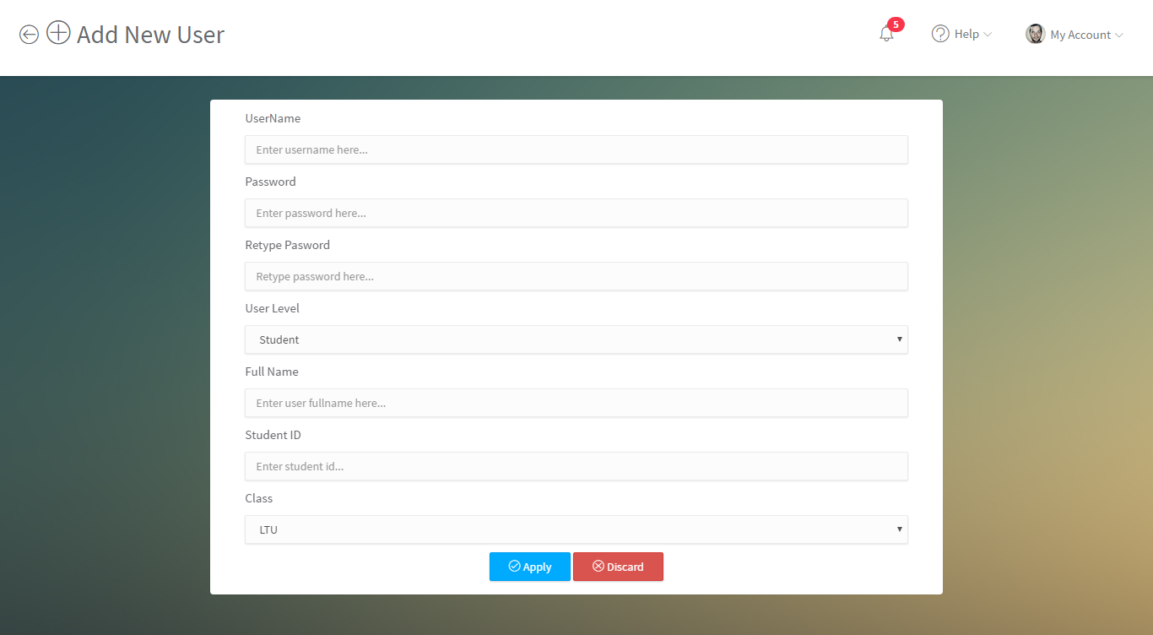

**3. All_topic**

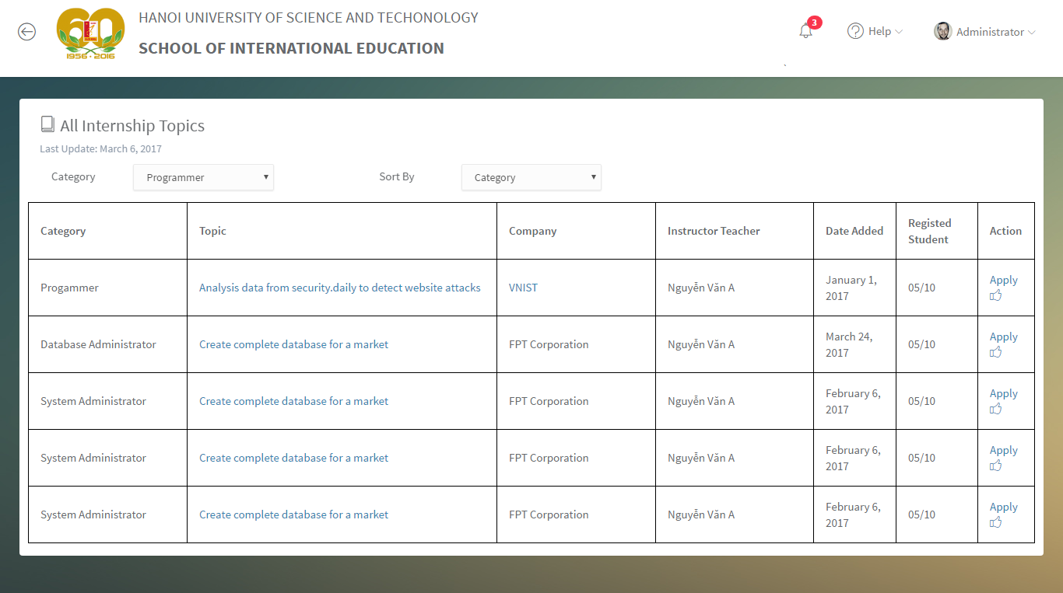

**4. Change_pass**

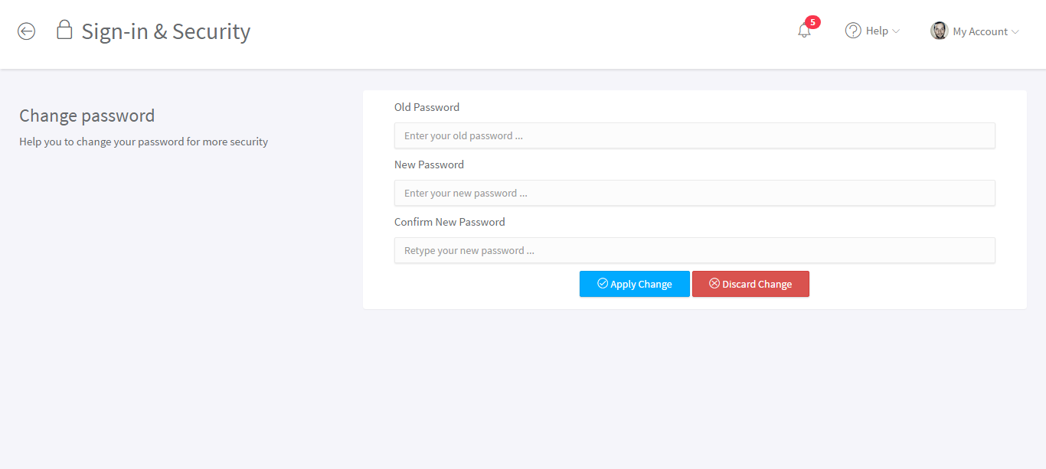

**5. Edit_point**

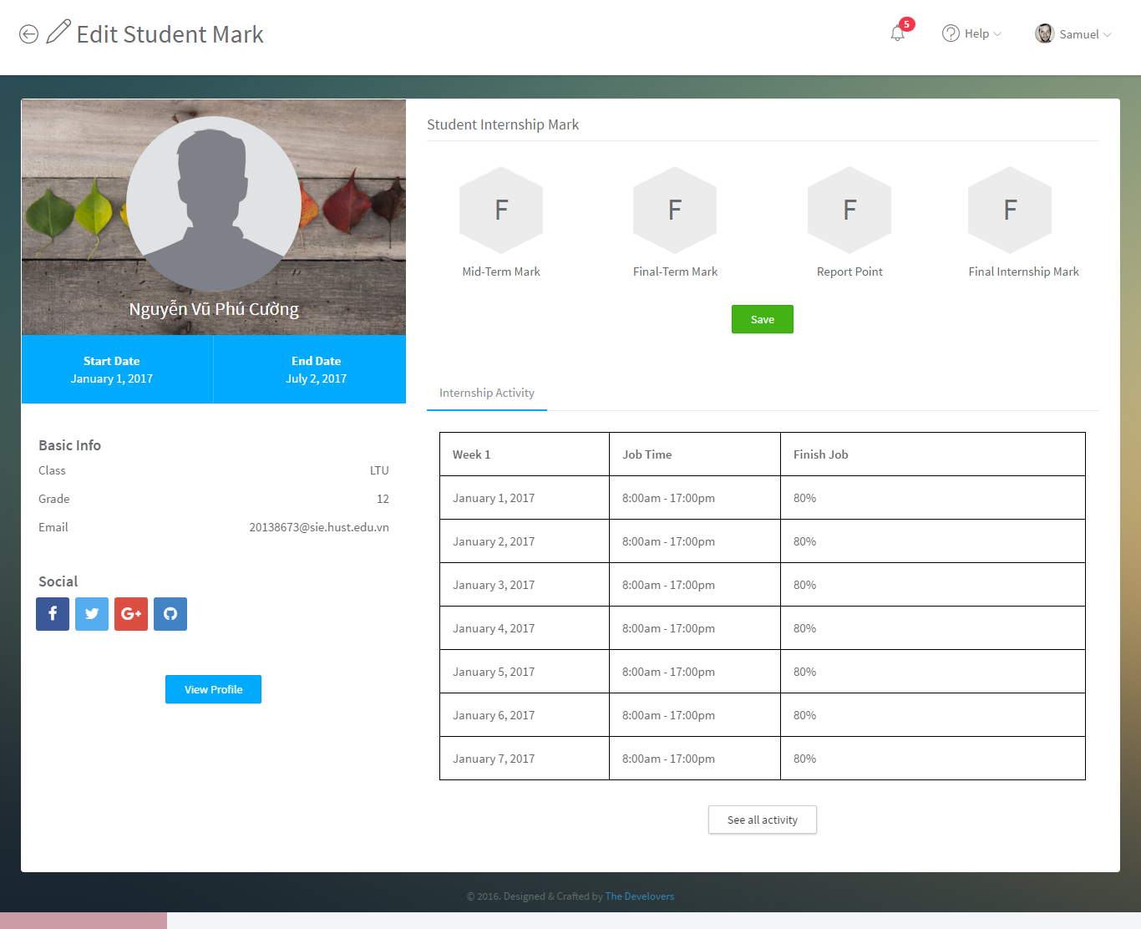

**6. Edit student**

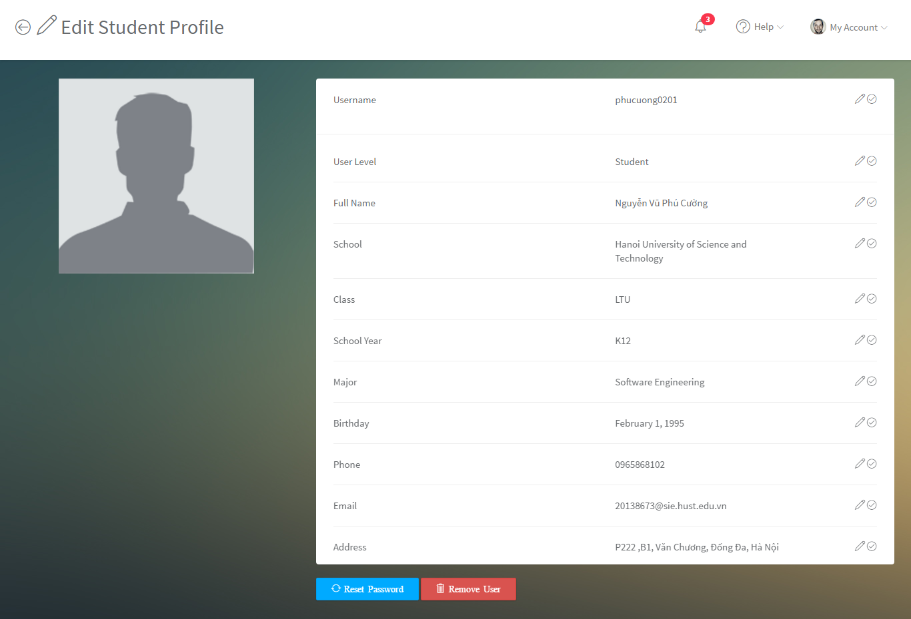

**7. Home guest**



**8. Home user**

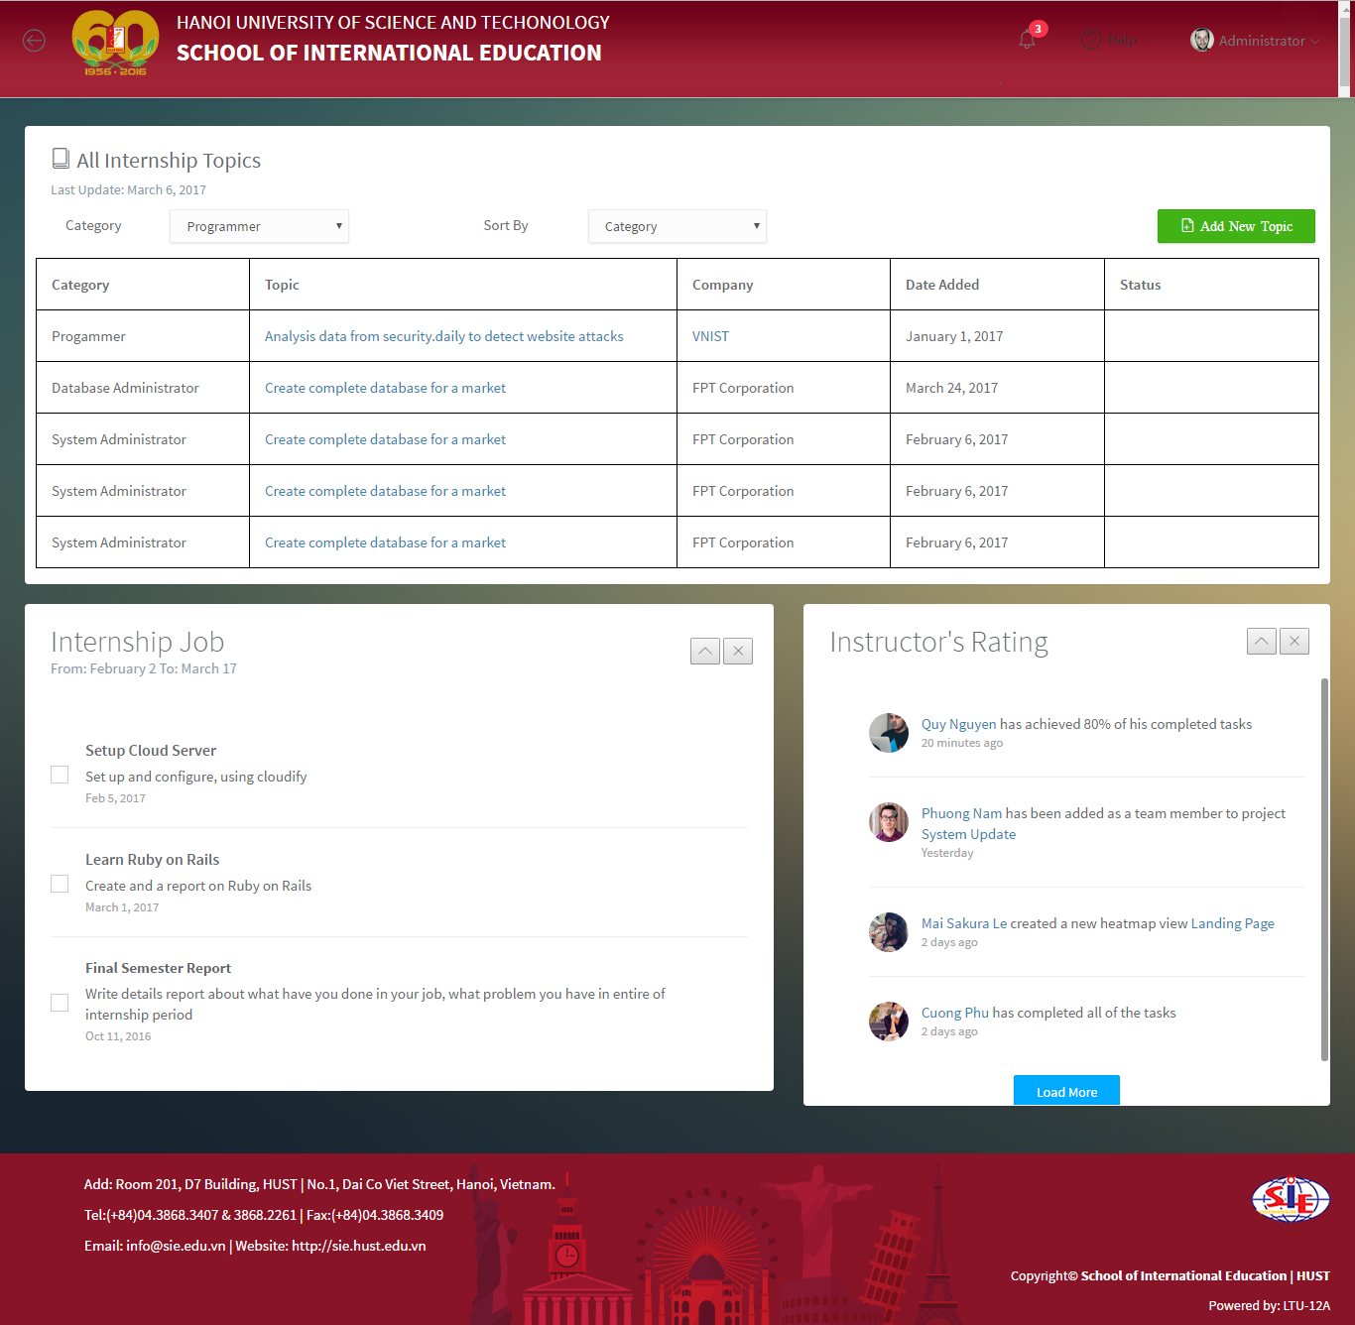

**9. Internship plan**

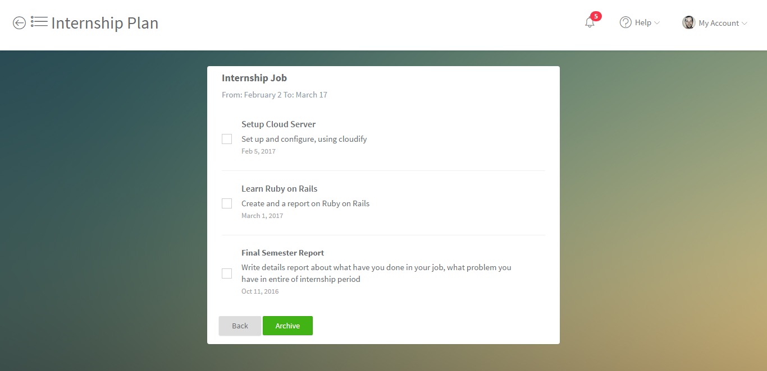

**10. Internship plan all**

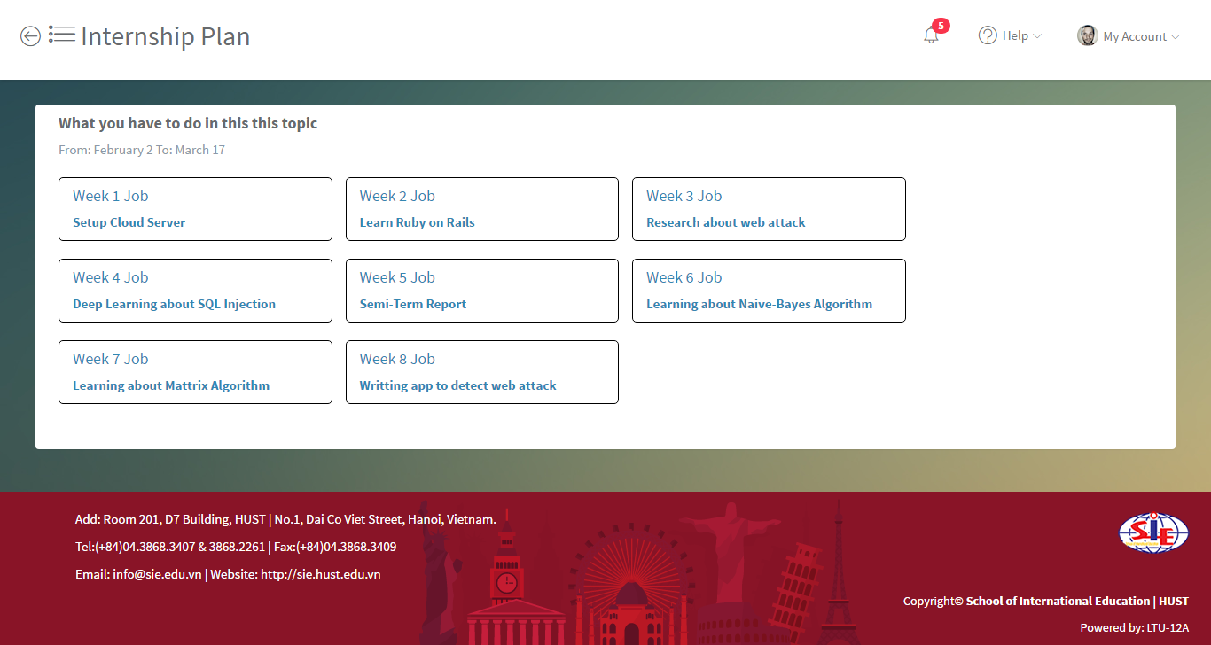

**11. Login_page**

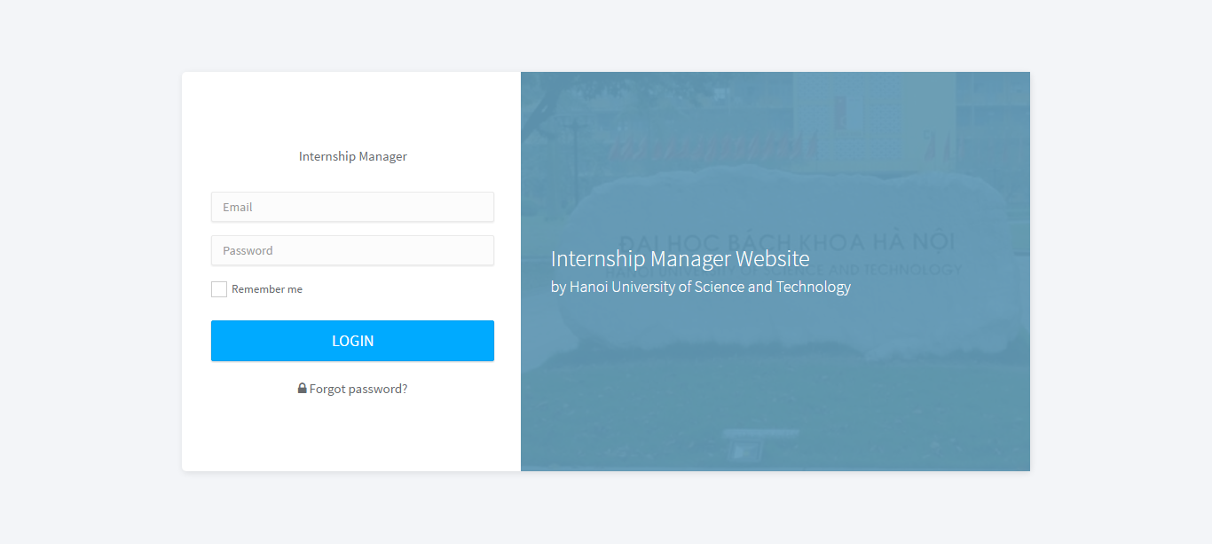

**12. Manage_cv**

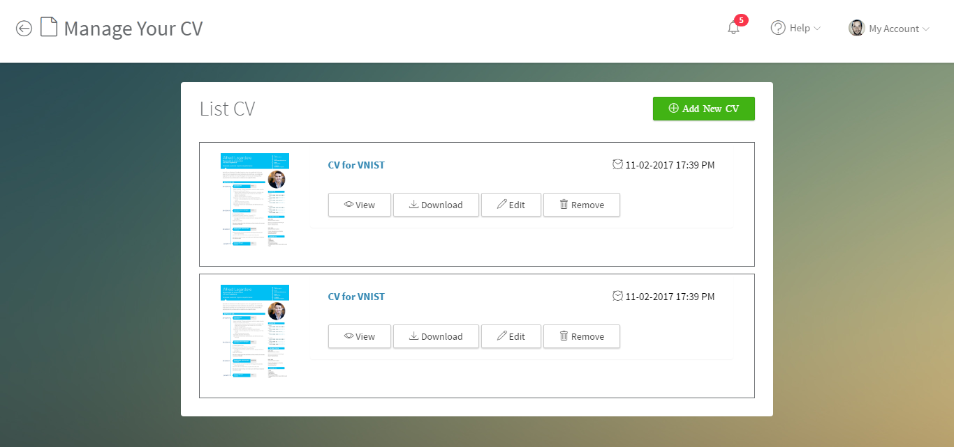

**13. Manage_point**

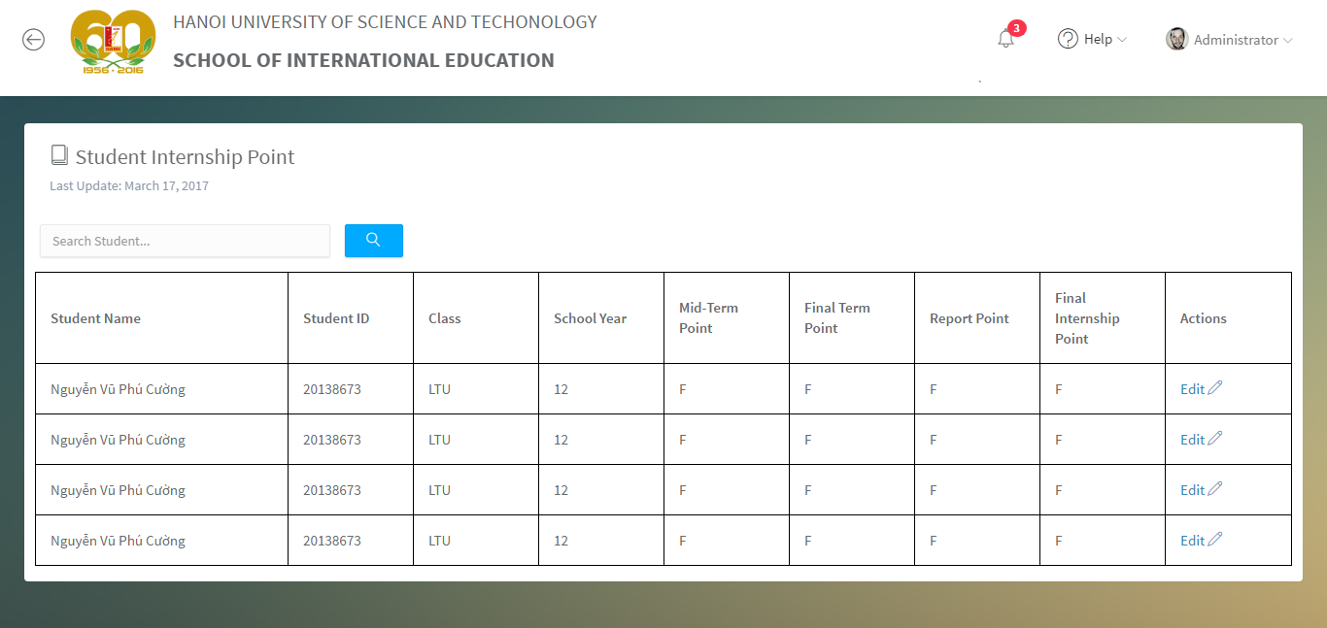

**14. Manage_student**

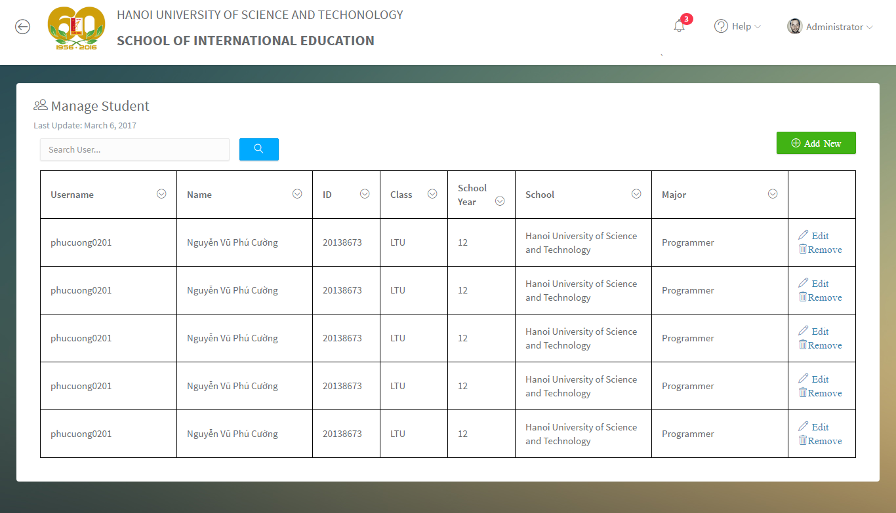

**15. Manage_teacher**

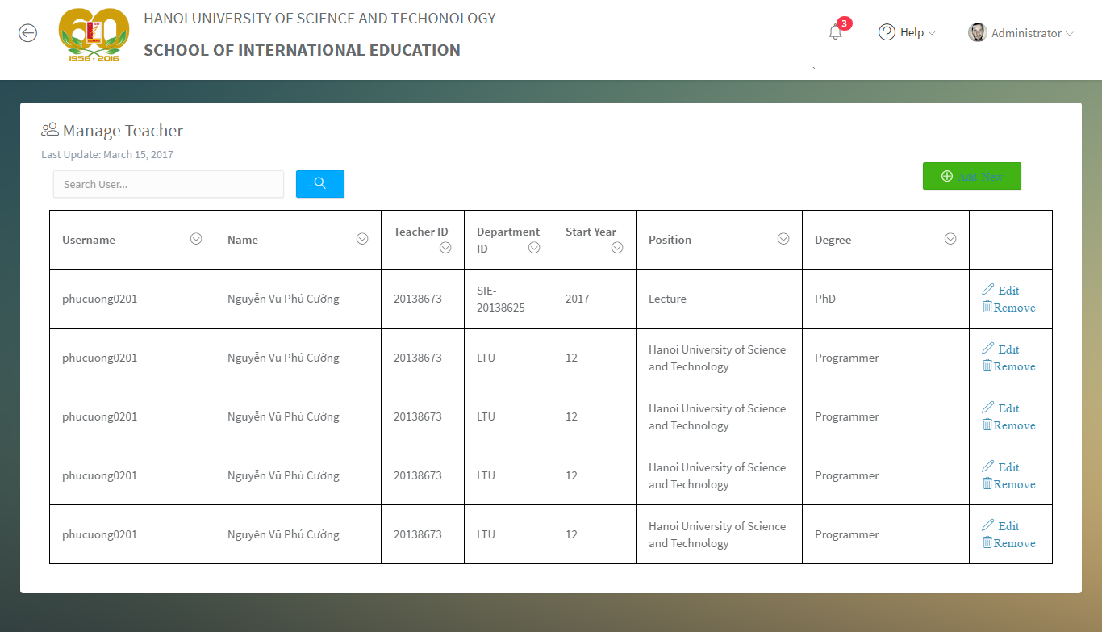

**16. New_CV**

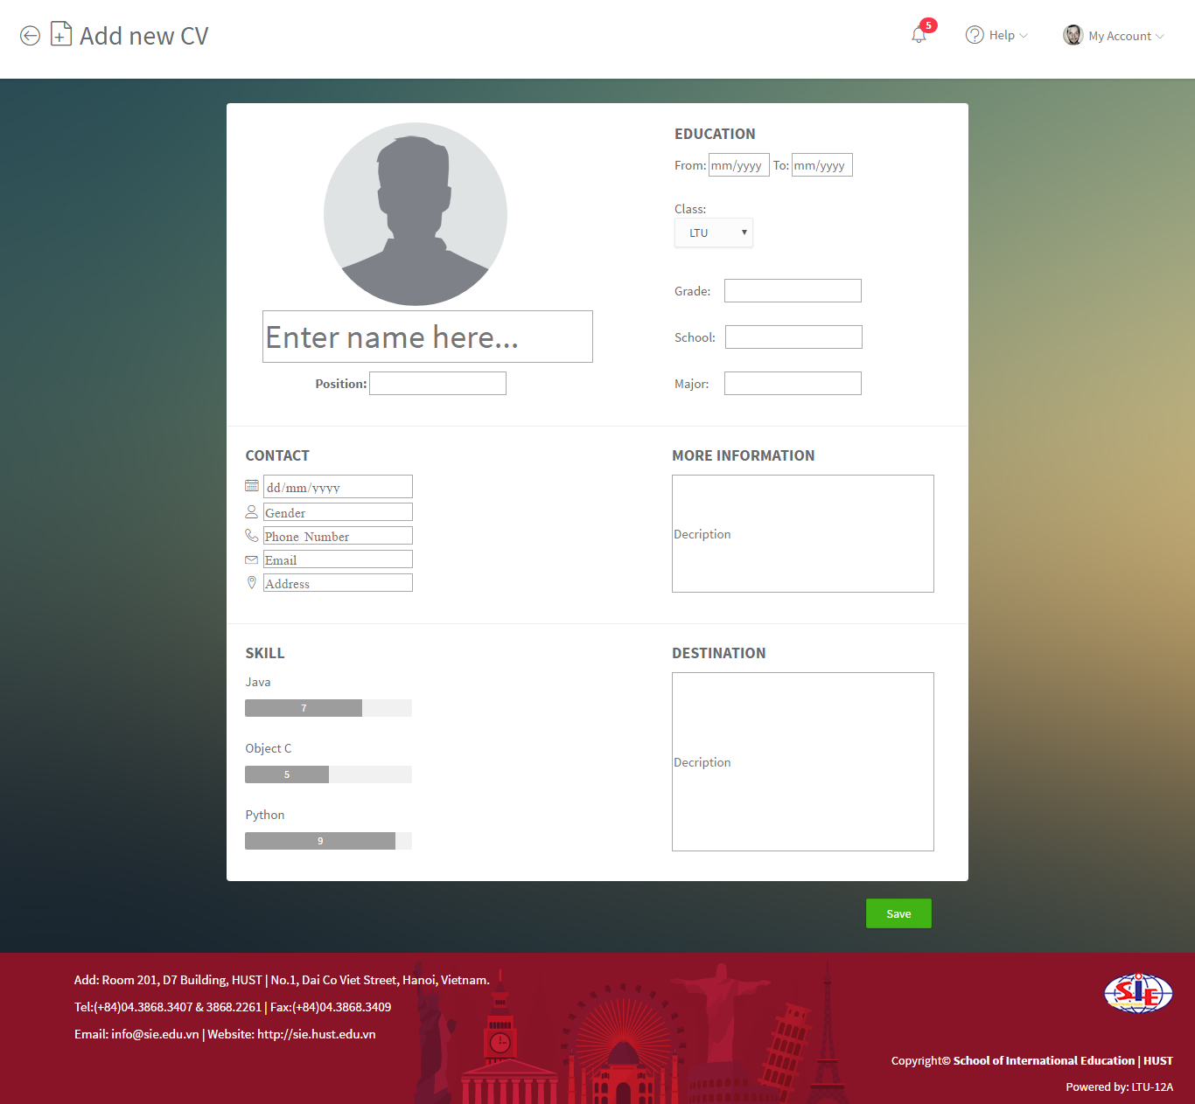

**17. Profile_info**

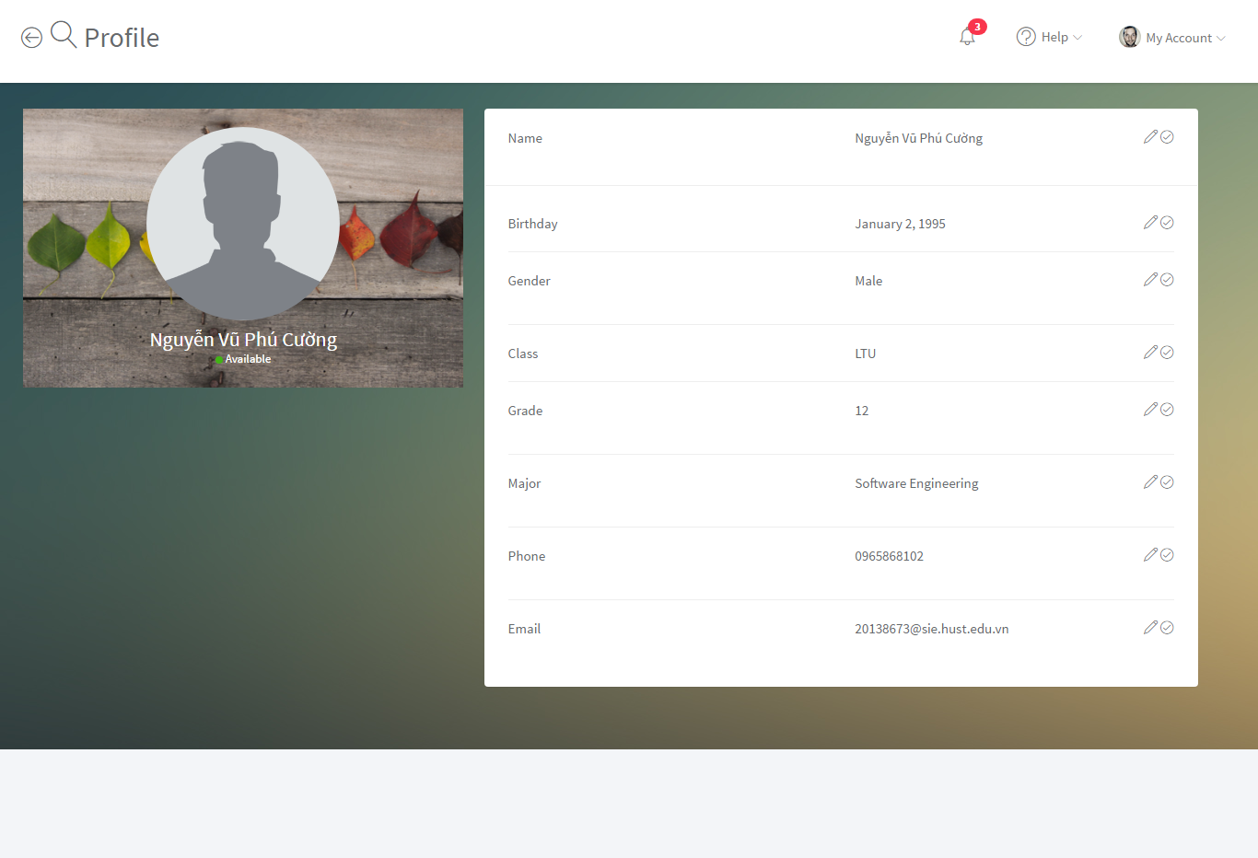

**18. Register_topic**

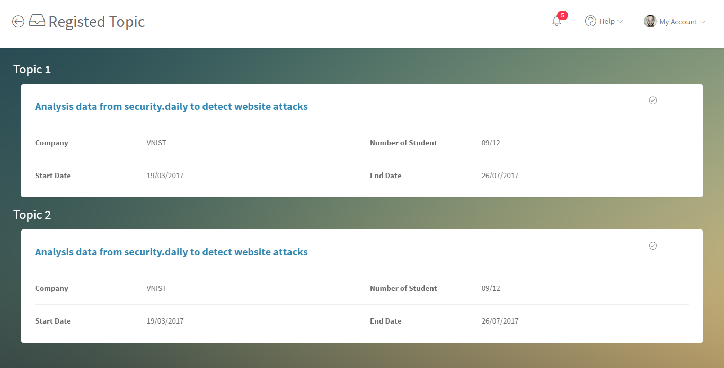

**19. Reset_pass**

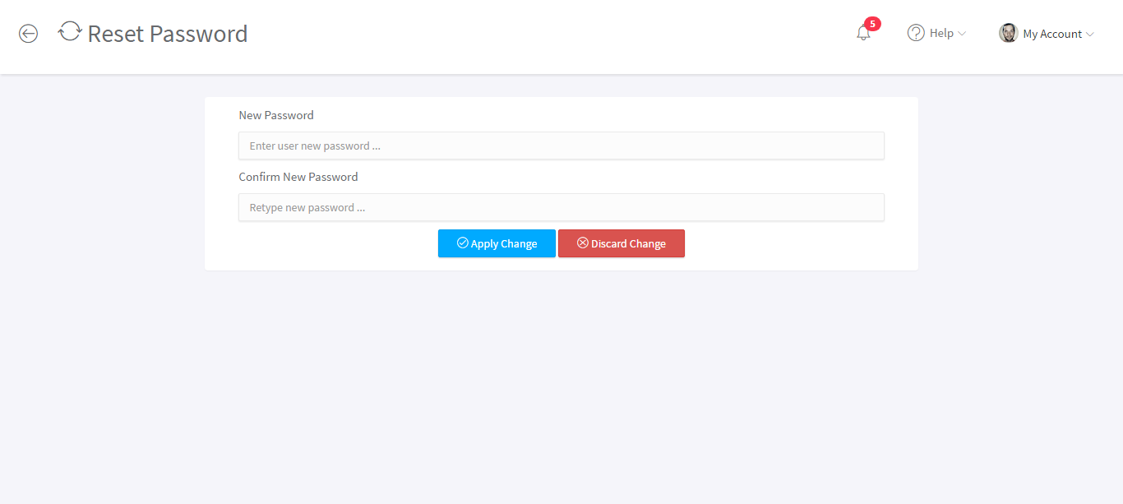

**20. Settings**

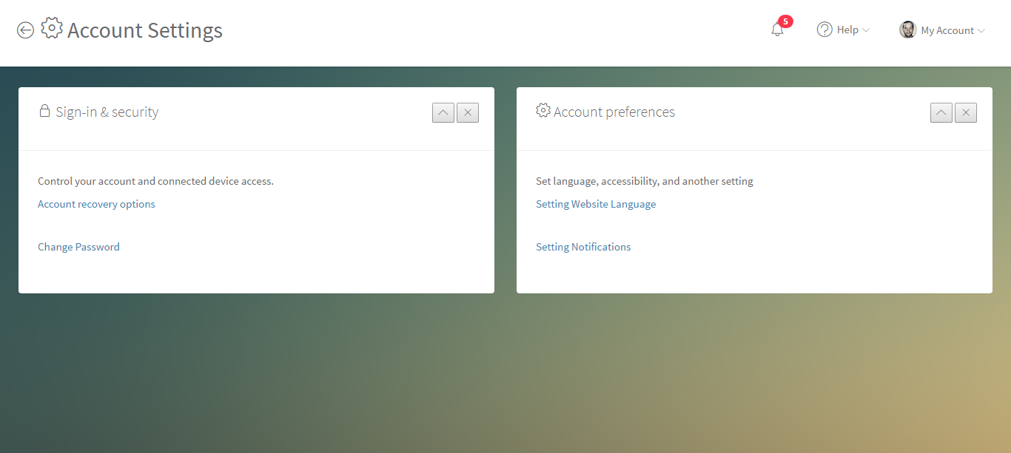

**21. Success_topic**

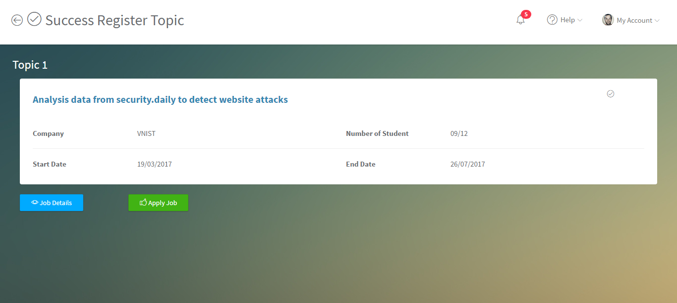

**22.Topic_detail**

